EXPERIMENT 1
Data Acquisition and Data Profiling using BI Tools

Aim:
To acquire data from multiple sources and perform data profiling using Microsoft Power BI in order to assess data quality, understand data structure, identify anomalies, and prepare data for further analytical processing.

Steps to Perform the Experiment:
Step 1: Open Power BI Desktop, select 'Get Data' from the Home ribbon, choose 'Text/CSV', and load the 'Sales_Data.csv' file.
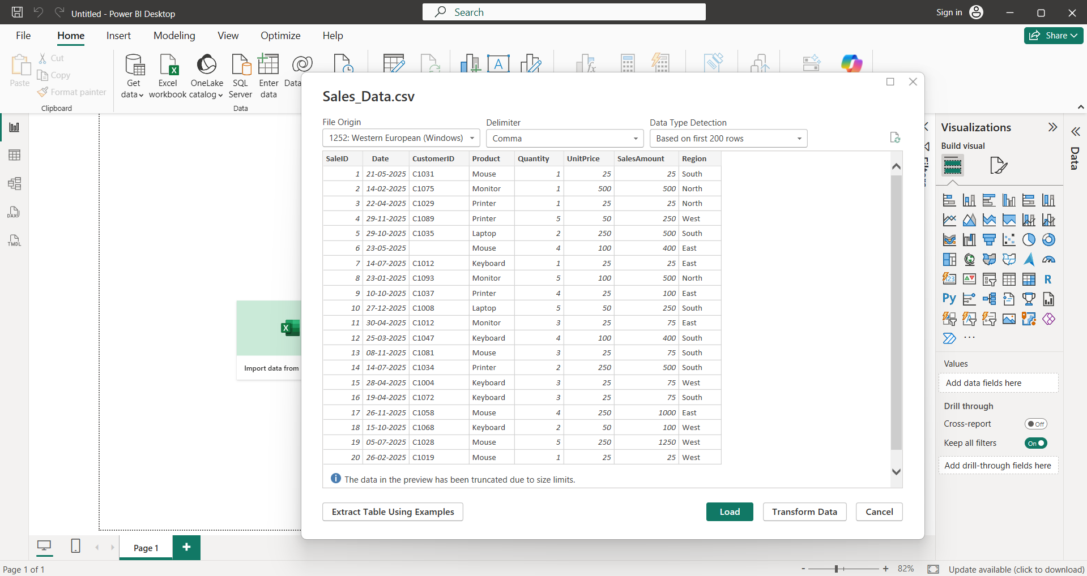

Step 2: Click on 'Get Data' again, select 'Excel Workbook', browse to find 'Employee_DB.xlsx', select the target sheet, and import it.
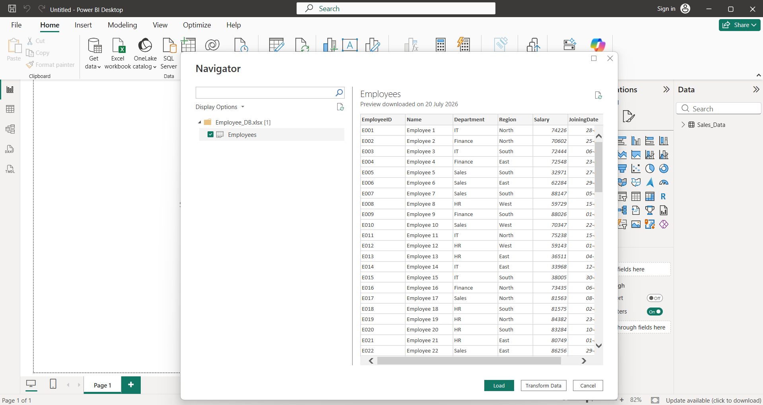

Step 3: Choose 'SQL Server' from 'Get Data', input your server credentials, select the 'Transactions' table, and click load to complete the imports.
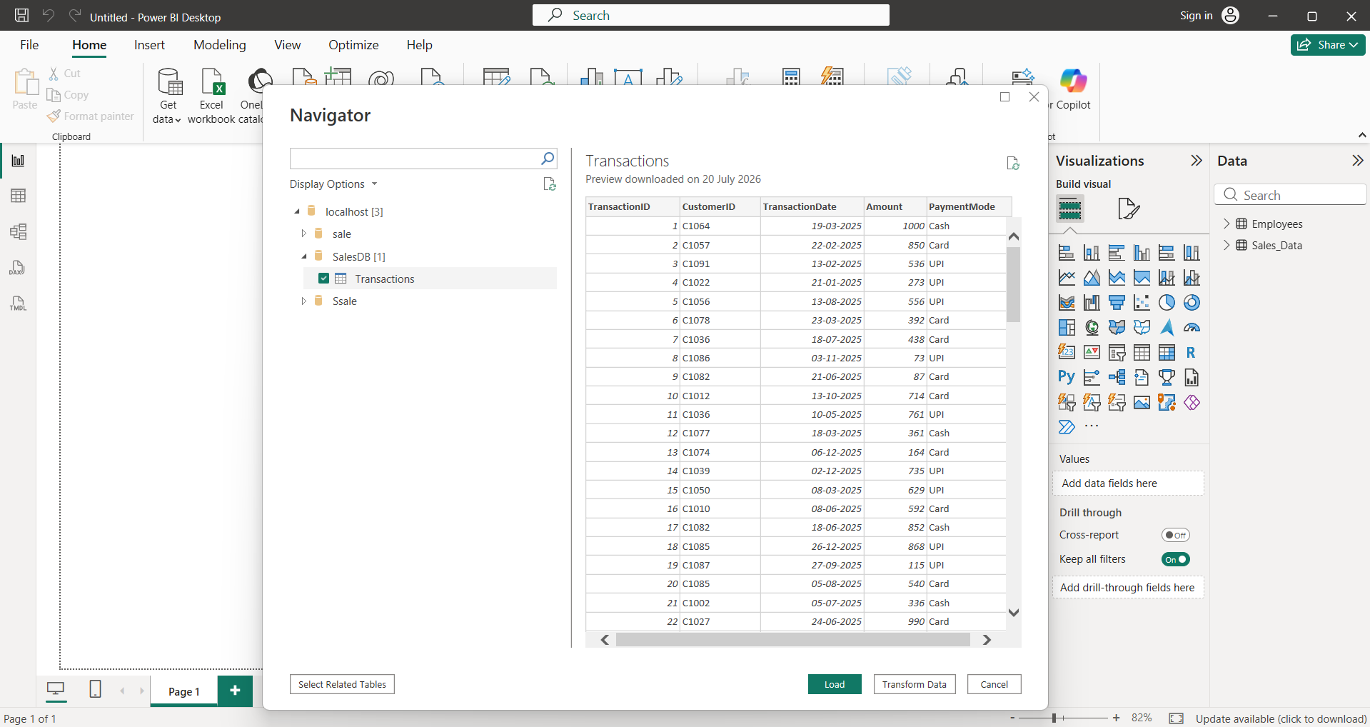

Step 4: Go to the Home tab on the top menu ribbon, look for the queries group, and click on 'Transform Data' to launch Power Query.
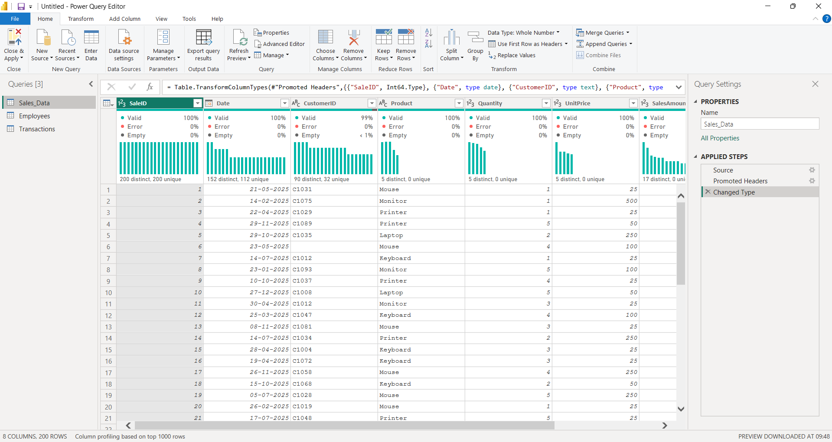

Step 5: Inside the Power Query window, navigate to the View tab and check the boxes for Column Quality, Distribution, and Profile.
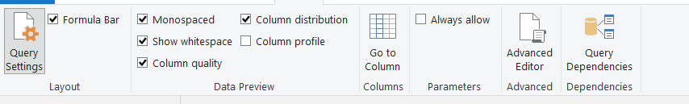

Step 6: Select each individual column one by one to view the data quality metrics, value frequencies, and distinct counts beneath the headers.

Step 7: Analyze the detailed summary statistics in the profile pane to spot data quality anomalies like null percentages, duplicates, or type mismatches.
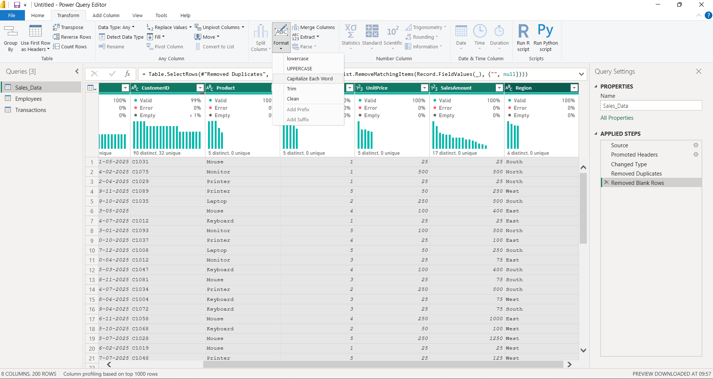
Learning Outcomes:
- Understand the core concepts of Business Intelligence, its architectural pipeline, and data acquisition methodologies.
- Identify and connect to multiple heterogeneous data source types using built-in connector interfaces within Power BI.
- Apply automated data profiling capabilities in Power Query Editor to validate dataset completeness, uniqueness, and structural formats.
- Interpret column statistics to diagnose data quality problems and formulate appropriate data cleaning and transformation procedures.

